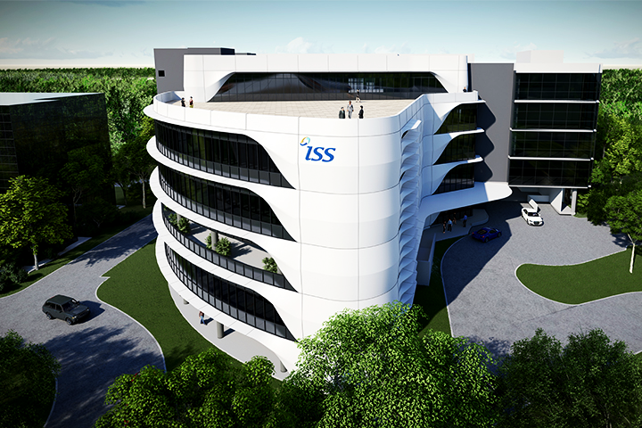

ISS Project –

**Intelligent Covid Detection and Chatbot Platform**

Hong Xiaohui (S9476943D)

Anita Koo Shi Qi ()

Sanjeven Ramakrishnan ()



National University of Singapore | Institute of Systems Science

https://github.com/xiaohuihong/IRS-PM-2021-05-01-IS03PT-GRP-3Musketeers-CoviDetector.git

**Table of Content**

1. Business Case 3

2. System Model 4

3. System Development & Implementation 5

3.1. System Architecture 5

3.1.1. Overview 5

3.2. Data Sources 6

3.2.1. Covid Symptoms and User Profile Data Set 6

3.2.2. Chatbot FAQ and Related Information 7

3.3. Knowledge Elicitation and Extraction 7

3.3.1. Manual Extraction 7

3.3.2. Web Scraper 7

3.4. Reasoning System 8

3.4.1. Overview 8

3.4.2. Decision trees and Decision rule learning 8

3.5. Cognitive System 9

3.5.1. Overview 9

3.5.2. Chatbot by FAQ 9

3.5.3. Chatbot by NLP 10

3.6. Web Application 10

4. Challenge and Conclusion 11

4.1. challenges 11

4.1.1. Balancing work and project 11

4.1.2. First time using Django framework 11

4.2. Future Improvements 11

4.2.1. Include database to store data 11

4.2.2. Real-time API for web scrape 11

4.2.3. Chatbot icon to be shown at the bottom right of the webpage 11

4.3. Conclusion 11

APPENDIX OF REPORT A 13

APPENDIX OF REPORT B 18

APPENDIX OF REPORT C 20

APPENDIX OF REPORT D 2

**Abstract:** With the recent low number of community cases of covid-19, mass gathering is allowed. However, participants will have to take an antigen rapid test for Covid-19 and obtain a negative result before admission. Hence, the event planner must ensure the participants safety/health condition before allowing participants to enter the event venue. This project proposes a solution to this problem by using a machine learning model to determine the likelihood of participants having Covid-19. In addition, it includes a chatbot to allow the participants to know current information about Covid-19 and the event itself.

# Business Case

Recent news reported that the Singapore government allowed mass gathering but with a requirement. Before a participant can enter the venue, the event organizer has to ensure that he/she is not contacted with Covid-19. To implement this, the event organizer will have to check with each participant individually on their health status before letting them in. As social distancing enforcement is a must, a long queue will be expected. Meaning, more manpower is needed to maintain the queue. If a shorter time can be implemented to handle these, the queue will be shorted thus lesser manpower is needed.

We propose that this can be handled with a web application (mobile-friendly) that has a survey for the participants to answer to get their health status. Participants with a mobile device would be able to answer the necessary questions before reaching the front of the queue. The result of the survey will let the queue maintainer either guide the participant to the swab test area or let the participant into the venue. Moreover, it also includes a chatbot that allows the user to know (real-time) information about Covid-19 and the event itself. This may keep the participants occupied while waiting for their turn to enter the venue. The solution may be tailored to suit different types of events.

# System Model

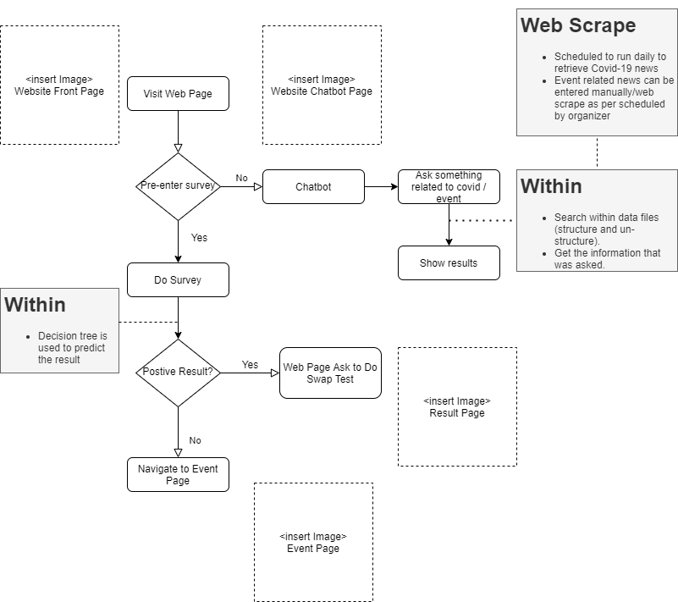

Figure 1 CovidDetector System - Flowchart

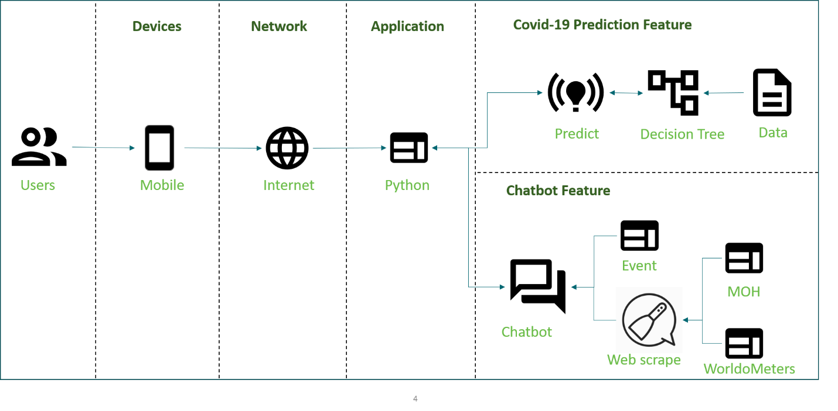

Figure 2 CovidDetector System - System General Design

# System Development & Implementation

## 3.1. System Architecture

### 3.1.1. Overview

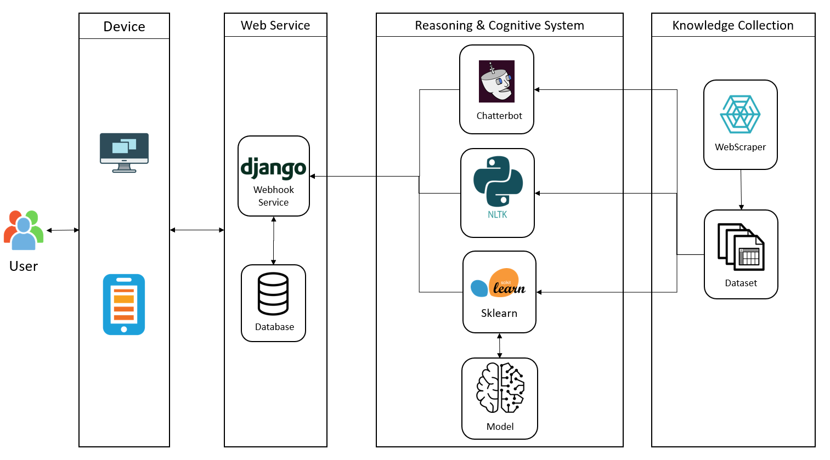

Figure 3 CovidDetector System - System Architecture

In order to build up a system which contains front-end and back-end and can integrate with machine learning libraries, as a result, Django, a python-based web framework, is decided to use this project. The other reason that we choose Django is it is built with SQLite database by default which is easier to help us deploy models.

Our eco-system is constituted by two components, predictive model for covid cases and chatbot for covid frequent questions. We choose to leverage scikit-learn which is a python library for predictive data analysis to build a model to predict if a user gets Covid-19 based on his symptoms and his profile. The chatbot consists of two types, one uses chatterbot which is a Python library that makes it easy to generate automated responses to a user’s input, and the other one is developed by scikit-learn and nature language tool kit to find out the most similar pattern from dataset based on user inputs. All of the knowledge and data are coming from web scraper which would run daily to refresh the knowledge base.

## 3.2. Data Sources

### 3.2.1. Covid Symptoms and User Profile Data Set

Our dataset comes from the Israeli Ministry of Health that publicly released data of all individuals who were tested for SARS-CoV-2 via RT-PCR assay of a nasopharyngeal swab. During the first months of the COVID-19 pandemic in Israel, all diagnostic laboratory tests for COVID-19 were performed according to criteria determined by the Israeli Ministry of Health. While subject to change, the criteria implemented during the study period included the presence and severity of clinical symptoms, possible exposure to individuals confirmed to have COVID-19, certain geographical areas, and the risk of complications if infected. Except for a small minority who were tested under surveys among healthcare workers, all the individuals tested had indications for testing. Thus, there was no apparent referral bias regarding the vast majority of the subjects in the dataset used in this study. In addition, all negative and positive COVID-19 cases in this dataset were confirmed via RT-PCR assay. Therefore, we can consider this dataset is genuine and reliable.

The following list describes each features of the dataset:

A. Basic information:

1). Sex (male/female)

2). Age ≥60 years (true/false)

B. Symptoms:

3). Cough (true/false)

4). Fever (true/false)

5). Sore throat (true/false)

6). Shortness of breath (true/false)

7). Headache (true/false)

C. Other information:

8). Known contact with an individual confirmed to have COVID-19 (true/false)

### 3.2.2. Chatbot FAQ and Related Information

To synchronize the knowledge base used by the chatbot with the frequently updated online webpage, the data extraction of the system is required to be executed daily. This can be done with the help of Cronjob external time scheduler, keeping the information updated automatically. This allows users to get the most accurate answers at any point of time while using the chatbot. The following table shows the websites we used to scrape the latest Covid-19 information.

|  |  |
| --- | --- |
| Websites | Data to Crawl |
| *https://www.who.int/news-room/q-a-detail/q-a-coronaviruses* | The WHO provides answers to frequently asked question regarding the coronavirus. |
| *https://www.worldometers.info/coronavirus/* | Infection Status across all countries |
| *https://www.moh.gov.sg/covid-19* | Latest updates & advisories from Ministry of Health, Singapore |

## Knowledge Elicitation and Extraction

### Manual Extraction

The covid symptoms and user profile data are recorded in Israeli originally but it has been translated into English Israeli analyst. We downloaded and extracted it from [*https://github.com/nshomron/covidpred*](https://github.com/nshomron/covidpred)

### Web Scraper

* 1. Beautiful Soup Python library:
     1. Visit the websites to retrieve Covid-19 related information.
     2. Study the html website and identify the information to extract.
     3. Html parser is utilised to extract the identified information.   
        Extract relevant information from the html and write to the data file.  
        Extract relevant urls and visit those websites to get relevant information.

## Reasoning System

### Overview

After discovering the knowledge base, we found out that we need to make a classification or prediction based on the values of known attributes or features as the final output of our model should be the result of Covid-19 that is positive and negative or we also can consider it as 0 and 1. Thus, we chose decision trees and decision rule learning as our predictive model.

### Decision trees and Decision rule learning

Before applying the model, we converted categories to numbers by one-hot and made do with N-1 binary variables, then the data would be as following.

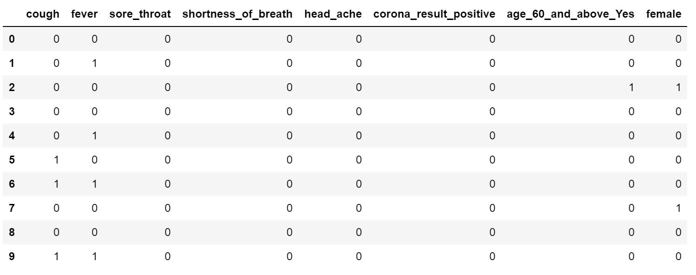

Figure 4 CovidDetector System - Sample Data after one-hotting

Usually, raw trees are often too big to be understandable, so we did pruning on the tree by min_samples_leaf=100 and max_depth=5 which means the minimum number of samples required to be at a leaf node is 100 and the maximum depth of the tree is 5. This pruning can improve accuracy by reducing overfitting and make the tree easier to understand. As a result, the tree is plotted as below.

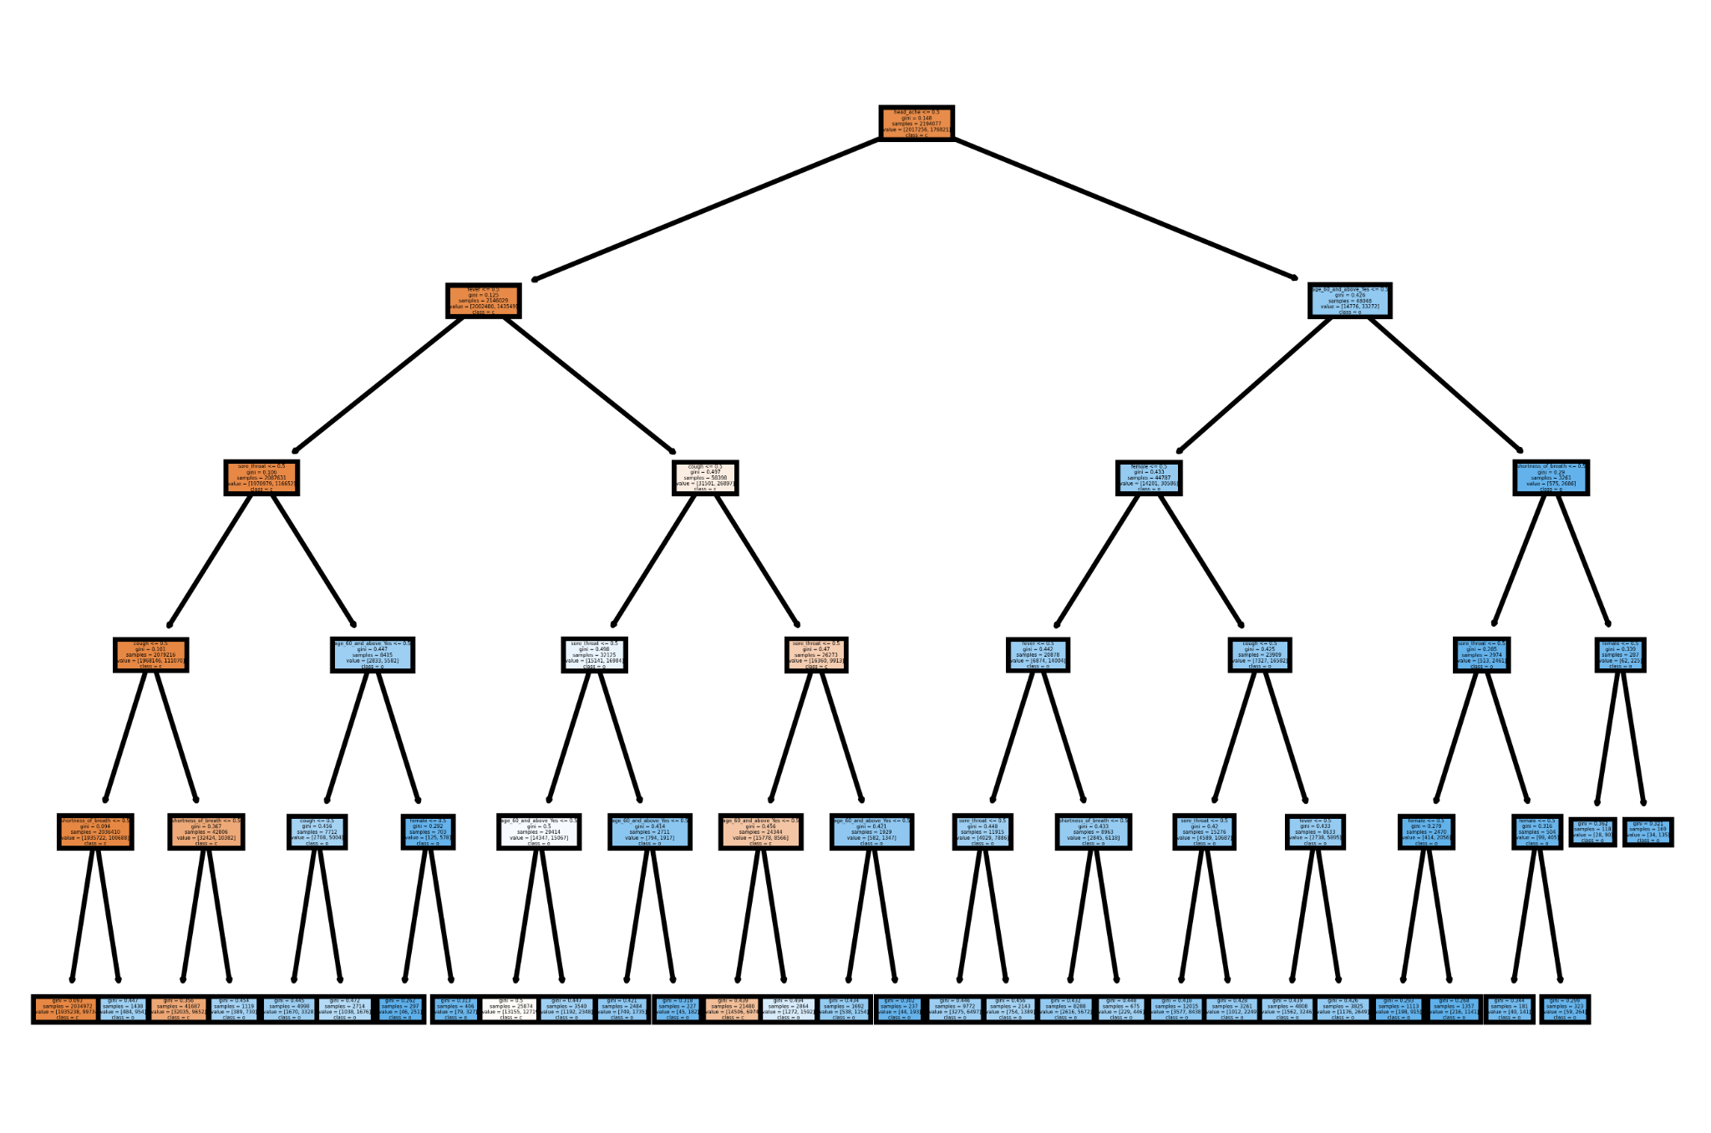

Figure 5 CovidDetector System - Decision Tree and Rules

The full size of tree and text presentation can be found in “SystemCode\CoviDetector\model\decision_tree_model.ipynb”.

The classification report is shown in the table below. As we can conclude, the general accuracy is 93% but the positive case (1) is only 68% although the negative case (0) is 94%. The reason that causes this is the number of positive cases in the sample is quite small. In the future, we can get more samples from MOH or the production data after this system is deployed to real use cases to improve the accuracy.

|  |  |  |  |  |
| --- | --- | --- | --- | --- |
|  | **precision** | **recall** | **f1-score** | **support** |
| **0** | 0.94 | 0.99 | 0.96 | 504365 |
| **1** | 0.68 | 0.27 | 0.39 | 44154 |
|  | | | | |
| **accuracy** |  |  | 0.93 | 548519 |
| **macro avg** | 0.81 | 0.63 | 0.67 | 548519 |
| **weighted avg** | 0.92 | 0.93 | 0.92 | 548519 |

## Cognitive System

### Overview

While participants enter an event, they could have a requirement to ask questions to understand the current situation about Covid-19 or the specific information about the event. We planned to build a FAQ chatbot to answer participants’ questions, but we found that it was not enough to respond to them precisely and it was hard for users to prepare a long worksheet about FAQ. So we decided to integrate FAQ chatbot and NLP chatbot to enhance its functionalities. Since we don’t have events’ details in this project, our data mainly focus on Covid-19 information.

### Chatbot by FAQ

We use Chatterbot Library, a Python library that makes it easy to generate automated responses to a user's input, to develop the FAQ chatbot. We applied the Jaccard Similarity algorithm that we learnt from course, Reasoning System, in the statement comparison function which means we calculate the similarity of user input and question list in FAQ worksheet based on the Jaccard index. In general, the Jaccard Similarity measures similarities between sets. It is defined as the size of the intersection divided by the size of the union of two sets that is concluded as the following formula.



The response selection method we used is get_first_response that the chatbot only returns the statement has the highest similarity. In addition, we set a threshold for the response’s confidence. The confidence value represents a rating of how accurate the logic adapter expects the selected response to be. Confidence scores are used to select the best response from multiple logic adapters. We used this threshold value to tell the system if it should switch the FAQ chatbot to NLP chatbot that is explained in section 3.5.3.

### Chatbot by NLP

Other than the FAQ list scraped from websites, we also scrawled some news and articles about Covid-19. When the FAQ cannot answer users’ questions, we can dig the responses from these news and articles.

After applying the common normalization methods like tokenization, case lowering, punctuation removal and lemmatization, we used tf-idf indexing as the vectorization method and leveraged cosine similarity algorithm as similarity measurement. The formula can be found as following:

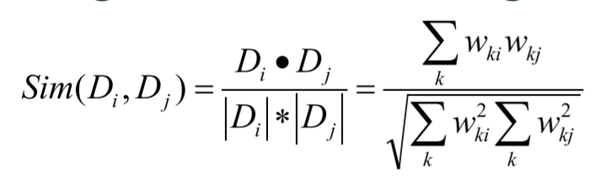

If the tf-idf value is zero, it means none of the words in user inputs appears in our dataset. The chatbot has to reply with an apology to the user, and our system would record down these statements to ask system admin and web scraper to prepare the necessary FAQ or extract the related information from websites.

## Web Application

Web application uses Django Web Framework along with CSS and JavaScript for these functions:

* + 1. User interface for users to answer the survey questions before ushered into the venue and for people to check event related information via our chatbot
    2. The user interface is form based and requires user inputs for the decision tree to predict the result
    3. Users may navigate to the “About” tab to get event information (e.g. queue waiting time etc). Since we do not have event information as of now, we put our system introduction instead to promote it.
    4. Users may navigate to the chatbot tab to seek information with regards to the event and Covid-19 that is not stated on the website.

# Challenge and Conclusion

## challenges

### Balancing work and project

The main challenge for our team is finding time to have meet-ups for project discussion because we have different work schedules (e.g. on different client sites, doing overtime and etc) .

### First time using Django framework

This is the first time we are using the Django framework thus it took us some time to figure out how to use it and create a base framework for the application.

## Future Improvements

If we have a longer timeframe to work on this project, we would have work on these areas:

### Include database to store data

A database could be added to store the survey answer, result and personal information (e.g name and last 4 char of NRIC) of every participant. If one of the participants happened to be a covid-19 confirmed case, necessary information could be provided to the relevant authorities for contact tracing.

### Real-time API for web scrape

Currently, the web scrape could only be triggered by schedule. With a real-time API and adding more relevant and trustable websites for web scrape, the user could be more informed of the latest news every time they ask a relevant question via the chatbot.

### Chatbot icon to be shown at the bottom right of the webpage

Currently, the chatbot is within a tab. However, the ideal placement for the chatbot should be at the bottom right of every web page. The reasons being, most of the people are right-handed and they will not be comfortable with the bottom left placement because they are used to things being catered for right-handed people. In addition, having a chatbot not within the webpage, users might forget the question to ask regarding the content when they clicked on a new tab.

## Conclusion

Our team has learned quite a few things while working on this project.

Technical wise, we picked-up Django and web scraping. Also, combining a few technical skills we learnt in the course to form a new one.

In addition, while completing this project, it shows us the importance of knowledge elicitation. Without it, the main features of this application will not be feasible. We used the knowledge to build the model for the Covid-19 prediction and utilised similarity-based reasoning on the knowledge base for the chatbot response.

Overall, it was a truly enjoyable process. We get to learn from one another and apply what we learned onto a solution which resolves an everyday problem in the current Covid-19 situation.

# APPENDIX OF REPORT A

Project Proposal

**GRADUATE CERTIFICATE: Intelligent Reasoning Systems (IRS)**

**PRACTICE MODULE: Project Proposal**

|  |
| --- |
| **Date of proposal:**  1 May 2021 |
| **Project Title:**  ISS Project – Intelligent Covid Detection and Chatbot Platform |
| **Sponsor/Client:** *(Name, Address, Telephone No. and Contact Name)*  Institute of Systems Science (ISS) at 25 Heng Mui Keng Terrace, Singapore  NATIONAL UNIVERSITY OF SINGAPORE (NUS)  Contact: Mr. GU ZHAN / Lecturer & Consultant  Telephone No.: 65-6516 8021  Email: [zhan.gu@nus.edu.sg](mailto:zhan.gu@nus.edu.sg) |
| **Background/Aims/Objectives:**  The proposed intelligent eco-system is aimed to integrate various advanced machine reasoning techniques to help screen vaccinated members of the public before they attend various events in Singapore, and to gather dynamic and heterogeneous information to build up an intelligent chatbot system to respond users’ questions about COVID-19. |
| **Requirements Overview:**   * Research, data collection and cleaning ability * Programming ability - python * System integration ability – Integration of Django, JQuery, Javascript, HTML, CSS and machine learning libraries |
| **Resource Requirements (please list Hardware, Software and any other resources)**  Hardware proposed for consideration:   * CPU   Software proposed for consideration:   * Pertained machine learning models, e.g. NLP, decision tree * machine learning tools, e.g. Python sklearn * Chat-bots, e.g. ChatterBot * Cognitive systems, e.g. nltk * Web crawler, e.g. beautifulsoup4 * Web framework, e.g. Django |
| **Number of Learner Interns required: (Please specify their tasks if possible)**  a team of three project members. Their completed tasks are specified in their individual reports. |
| **Methods and Standards:**   |  |  |  | | --- | --- | --- | | **Procedures** | **Objective** | **Key Activities** | | | **Requirement Gathering and Analysis** | The team should meet with ISS to scope the details of project and ensure the achievement of business objectives. | 1.        Gather & Analyze Requirements | | 2.        Define internal and External Design | | 3.        Prioritize & Consolidate Requirements | | 4.        Establish Functional Baseline | | **Technical Construction** |  | 1.        Setup Development Environment | | To develop the source code in accordance to the design. | 2.        Understand the System Context, Design | | 3.        Perform Coding | | 4.        Conduct Unit Testing | | **Integration Testing and acceptance testing** | To ensure interface compatibility and confirm that the integrated system hardware and system software meets requirements and is ready for acceptance testing. | 1.        Prepare System Test Specifications | | 2.        Prepare for Test Execution | | 3.        Conduct System Integration Testing | | 4.        Evaluate Testing | | 5.        Establish Product Baseline | |  | | **Acceptance Testing** | To obtain ISS user acceptance that the system meets the requirements. | 1.        Plan for Acceptance Testing | | 2.        Conduct Training for Acceptance Testing | | 3.        Prepare for Acceptance Test Execution | | 4.        ISS Evaluate Testing | | 5.        Obtain Customer Acceptance Sign-off | |  | | **Delivery** | To deploy the system into production (ISS standalone server) environment. | 1.        Software must be packed by following ISS’s standard | | 2.        Deployment guideline must be provided in ISS production (ISS standalone server) format | | 3.        Production (ISS standalone server) support and troubleshooting process must be defined. | |  | |

**Team Formation & Registration**

|  |
| --- |
| Team Name:  3Musketeers |
| Project Title (repeated):  ISS Project – Intelligent Covid Detection and Chatbot Platform |
| System Name (if decided):  CoviDetector |
|  |
| Team Member 1 Name:  Hong Xiaohui |
| Team Member 1 NRIC Number:  S9476943D |
| Team Member 1 Contact (Mobile/Email):  +65-97805666 / xiaohui.hong@ncs.com.sg |
|  |
| Team Member 2 Name:  Anita Koo Shi Qi |
| Team Member 2 NRIC Number: |
| Team Member 2 Contact (Mobile/Email):  +65-96216596 / anita.koo@ncs.com.sg |
|  |
| Team Member 3 Name:  Sanjeven Ramakrishnan |
| Team Member 3 NRIC Number: |
| Team Member 3 Contact (Mobile/Email):  +65-98153769 / sanjeven.ramakrishnan@ncs.com.sg |
|  |

|  |  |  |
| --- | --- | --- |
| **For ISS Use Only** | | |
| **Programme Name:** | **Project No:** | **Learner Batch:** |
| **Accepted/Rejected/KIV:** | | |
| **Learners Assigned:** | | |
| **Advisor Assigned:**  Contact: Mr. GU ZHAN / Lecturer & Consultant  Telephone No.: 65-6516 8021  Email: [zhan.gu@nus.edu.sg](mailto:zhan.gu@nus.edu.sg) | | |

# APPENDIX OF REPORT B

Mapped System Functionalities against knowledge, techniques and skills of modular courses

|  |  |
| --- | --- |
| Modular Courses | System Functionalities / Techniqe Applied |
| Machine Reasoning (MR) | * **Knowledge Elicitation and Extraction**:  Web crawling from websites   Manual extraction from Israeli MOH dataset   * **Business rule and Business process**   Restrict rules to allow the vaccinated user to process the business rules   * **Constraint Satisfaction**   Setup threshold for the similarity of knowledge chatbot response and auto-switch to the chatbot of content based filtering   * **Rule Based System**:   Decision tree to derive rules from COVID-19 symptoms and user profile   * **Knowledge Discovery & Reasoning**:   Knowledge Chatbot developed by Chatterbot based on FAQ worksheet   * **Knowledge Representation**:  Decision tree diagram for COVID-19 symptoms   Classification report and confusion matrix table for the training results  Data representation in django SQLite database |
| Reasoning System (RS) | * **Knowledge Discovery & Transparency**:   Decision trees and Decision rule learning, including One-Hot Encoding, on predicting covid based on symptoms  Similarity-based Reasoning, including Similarity & Distance Measures by Cosine Similarity, on chatbot response from covid knowledge base |
| Cognitive System (CGS) | * **Cognitive System**:   Chatbot developed by Nature Language Processing, tf-idf indexing and Similarity Measurements |

# APPENDIX OF REPORT C

Installation and User Guide  
(Refer to separate document for Application & Deployment User Manual)

# Requirements

## Prerequisite

* Computer with internet access
* Python 3.6 installed

## Recommended browsers

Our screening system supports the following browsers:

* Microsoft Edge version 90 and above
* Google Chrome version 90 and above
* Opera 75 and above

# System Overview

Our Covid-19 event screener application is targeted at event organisers who would be managing crowd at large events. In our current setting in Singapore, event goers who have completed their vaccination do not have to go through the PCR test or any form of tests before entering the venue. However, there are cases where vaccinated personnel have caught the virus after vaccination. As such, our screener is targeted at participants who have completed their vaccination to serve as an extra layer of protection.

Besides providing screening, Our system also has a chatbot which serves as an FAQ bot answering questions related to Covid-19 or the event that is taking place.

# Deployment

Our system is deployed to a windows server. In order to run our system locally, you would need python 3.6 installed along with the following packages. These packages can also be installed via the requirements files provided.

To get started, we can download the source code at <https://github.com/xiaohuihong/IRS-PM-2021-05-01-IS03PT-GRP-3Musketeers-CoviDetector.git> or via the git clone command below:



Navigate to \SystemCode\CovidDectector\webscrape folder. Install the required packages and start webscrapping. The script can be scheduled to run daily using window scheduler for window os or crontab on linux os.

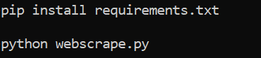

Navigate to the folder \SystemCode\CoviDetector and we will then proceed to install the required packages and start up the server locally with the following commands:



# User interface

Once the server is running, use your preferred browser to visit the link localhost:8000. We would recommend using Google chrome. We have three main sections to our application. Home, FAQ Bot and About.

Landing Page

This is the page users will first see when they access the application. From here, they are able to either start the questionnaire, access the FAQ bot or to read about the application.

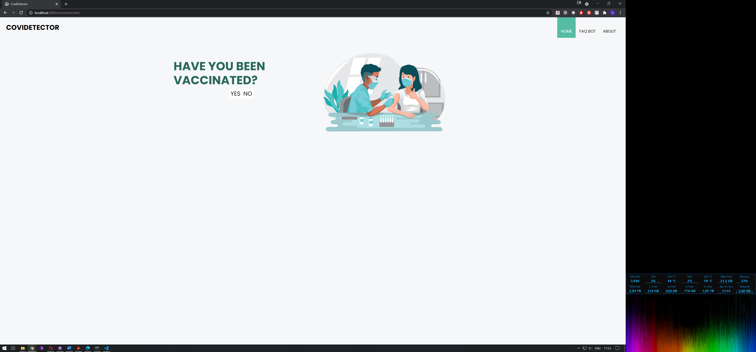

*Image 1: Landing page*

FAQ Bot

Here, users will have access to our FAQ bot and would be able to ask questions regarding Covid-19 or the event taking place.

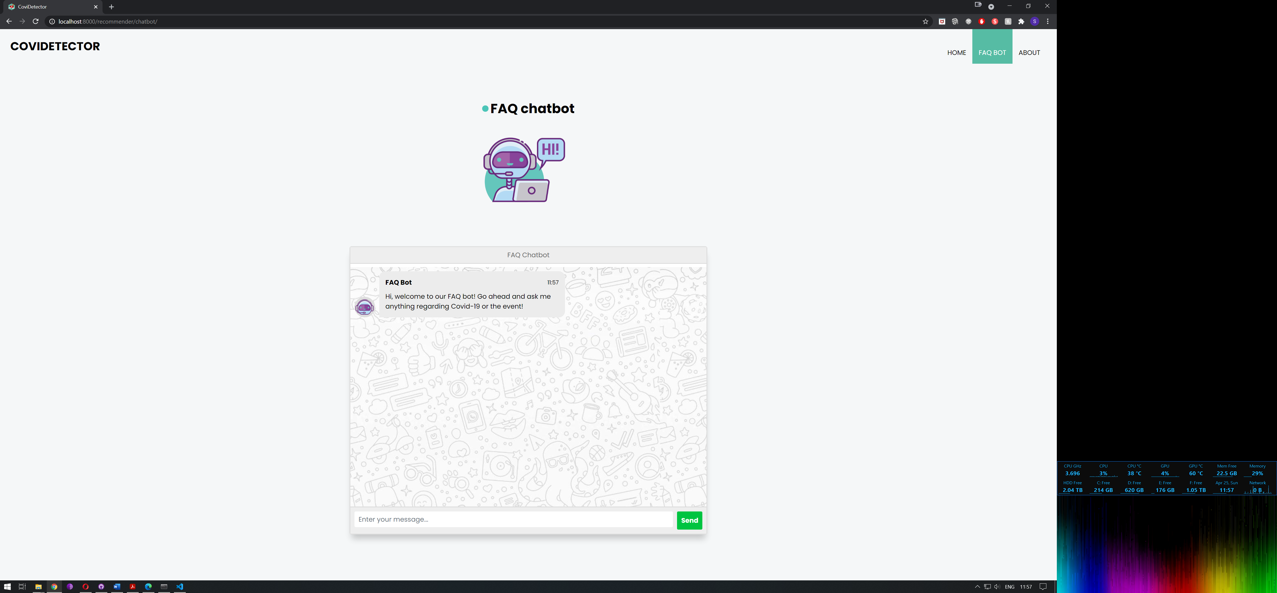

*Image 2: FAQ Bot*

About Page

Users will be able to read more about the project and the developers involved here.

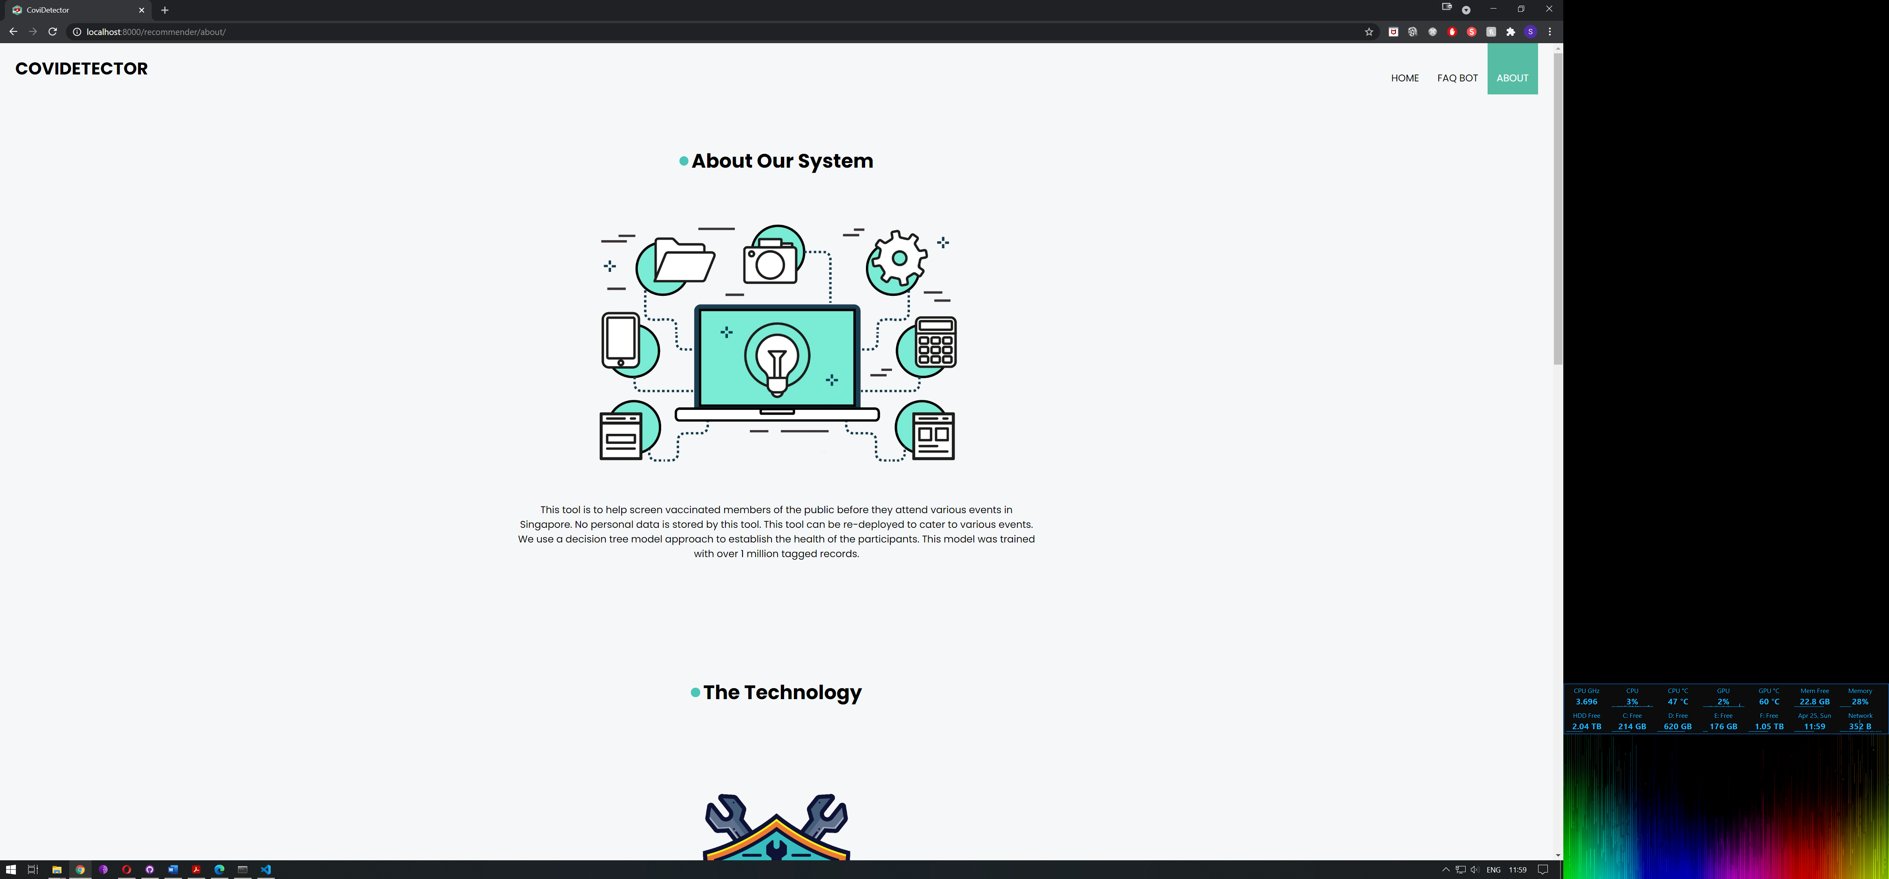

*Image 3: About us*

# Questionnaire

Users will go through the following questions:

1. Have you been vaccinated?
2. What is your age?
3. Have you been overseas in the last 14 days?
4. Have you been in contact with someone with COVID-19?
5. What is your gender?
6. Do you have cough?
7. Are you experiencing breath shortness?
8. Are you running a fever?
9. Do you have a sore throat?
10. Do you have a headache?

|  |  |  |  |
| --- | --- | --- | --- |
| **S/N** | **Question** | **User Interface** | **Possible answers** |
| 1 | Have you been vaccinated? |  | Yes – Proceed with the questionnaire  No – The questionnaire will end as we are targeting vaccinated participants. They will be directed to S/N 11 |
| 2 | What is your age? |  | Yes – Proceed with the questionnaire and response will be collected for processing  No – Proceed with the questionnaire and response will be collected for processing |
|  |  |  |  |
| 3 | Have you been overseas in the last 14 days? |  | Yes – Proceed with the questionnaire and response will be collected for processing  No – Proceed with the questionnaire and response will be collected for processing |
| 4 | Have you been in contact with someone with COVID-19? |  | Yes – Proceed with the questionnaire and response will be collected for processing  No – Proceed with the questionnaire and response will be collected for processing |
|  |  |  |  |
| 5 | What is your gender? |  | Yes – Proceed with the questionnaire and response will be collected for processing  No – Proceed with the questionnaire and response will be collected for processing |
| 6 | Do you have cough? |  | Yes – Proceed with the questionnaire and response will be collected for processing  No – Proceed with the questionnaire and response will be collected for processing |
|  |  |  |  |
| 7 | Are you experiencing breath shortness? |  | Yes – Proceed with the questionnaire and response will be collected for processing  No – Proceed with the questionnaire and response will be collected for processing |
| 8 | Are you running a fever? |  | Yes – Proceed with the questionnaire and response will be collected for processing  No – Proceed with the questionnaire and response will be collected for processing |
|  |  |  |  |
| 9 | Do you have a sore throat? |  |  |
| 10 | Do you have a headache? |  | Yes – Proceed with the questionnaire and response will be collected for processing  No – Proceed with the questionnaire and response will be collected for processing |
|  |  |  |  |
| 11 | Results page |  | The results collected previously will be analysed based on our trained model and displays a results page. |

*Table 1: Depicting the questionnaire flow*

# FAQ Chatbot

The chat bot uses the previously scrapped data to display the latest and relevant information pertaining to Covid-19 and the event. Users will be able to use the chat bot by navigating to the FAQ bot tab in the top right and key in their questions in the space provided.

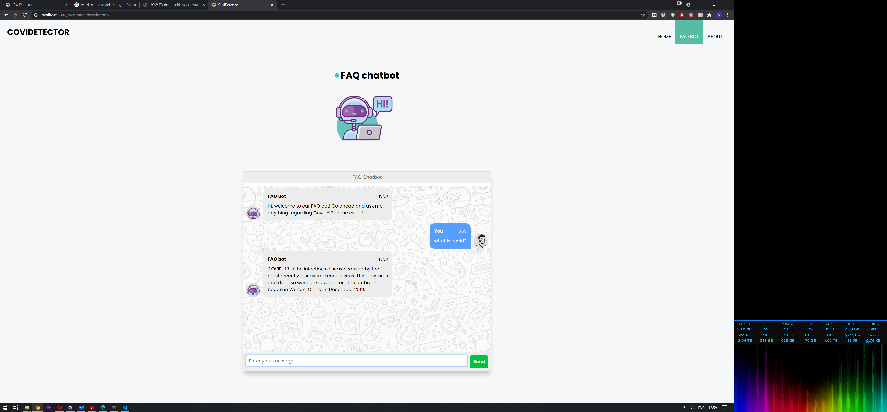

*Image 4: Chatbot replying to covid related questions*

As our solution is dynamic we are able to change the events content to suit each individual event. For demonstration purposes, we are using a Westlife concert as an example.

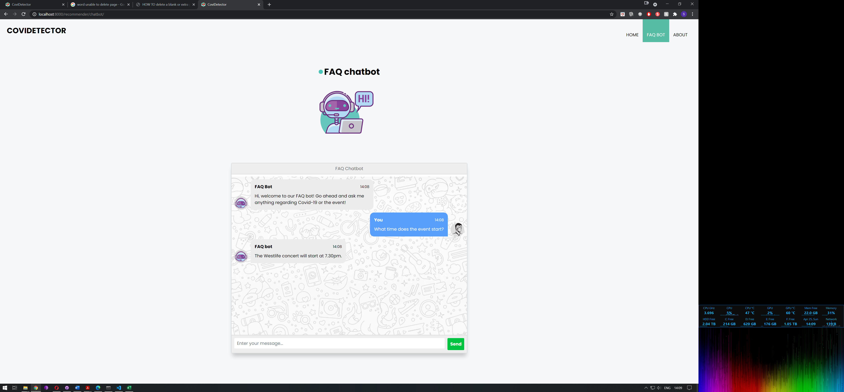

*Image 5: Chatbot replying to events questions*

# APPENDIX OF REPORT D

Individual Reports

### Individual Report by Hong Xiaohui (S9476943D)

**(1) personal contribution to group project**

**(2) what learnt is most useful for you**

**(3) how you can apply the knowledge and skills in other situations or your workplaces**